Snowflake Queries & Outputs
1.Create database & table
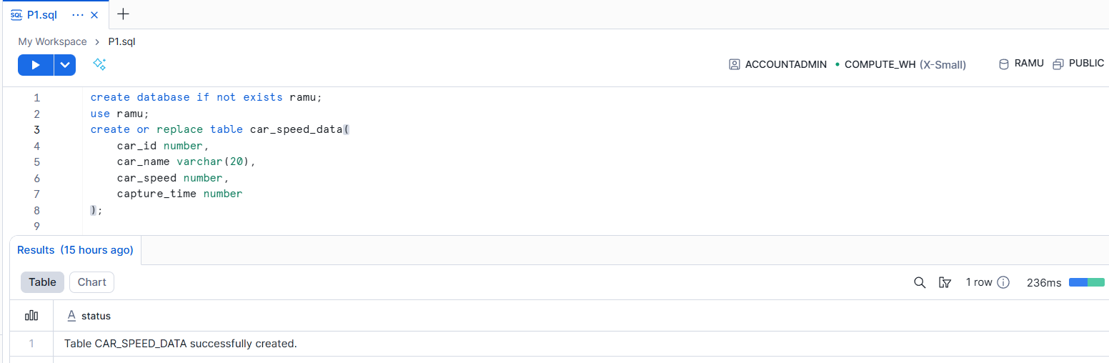
2. Displaying last 100 rows in real-time as data is being ingested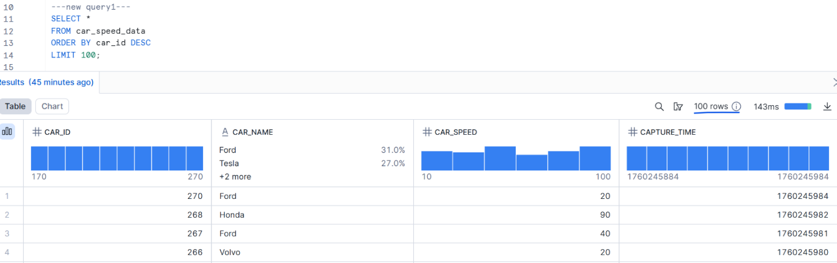
3. Sorting by descending order of speed, limiting to 30 rows
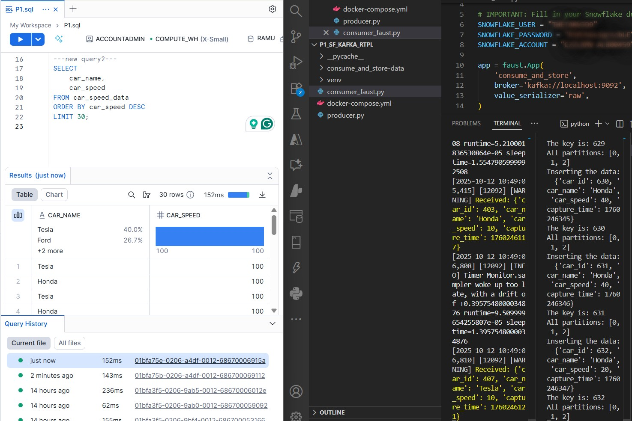
4. Grouping by descending order of avg speed
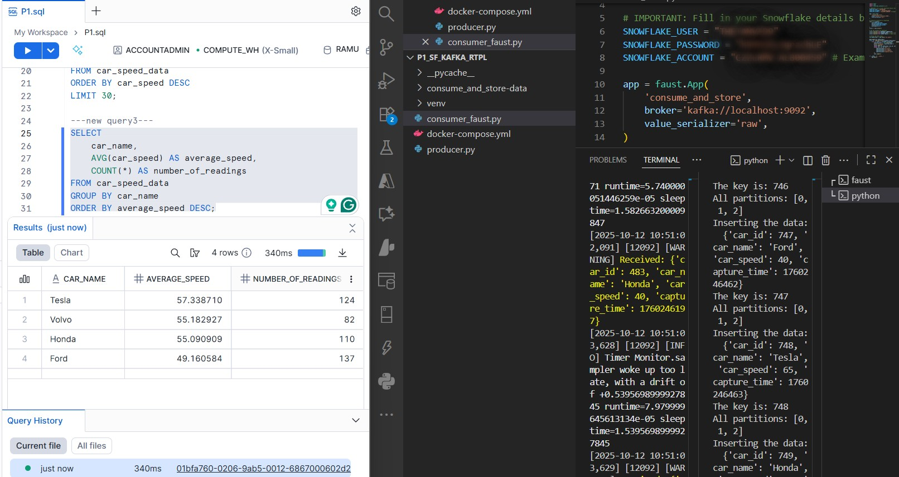
5. Calculating & Displaying min, max, avg speed
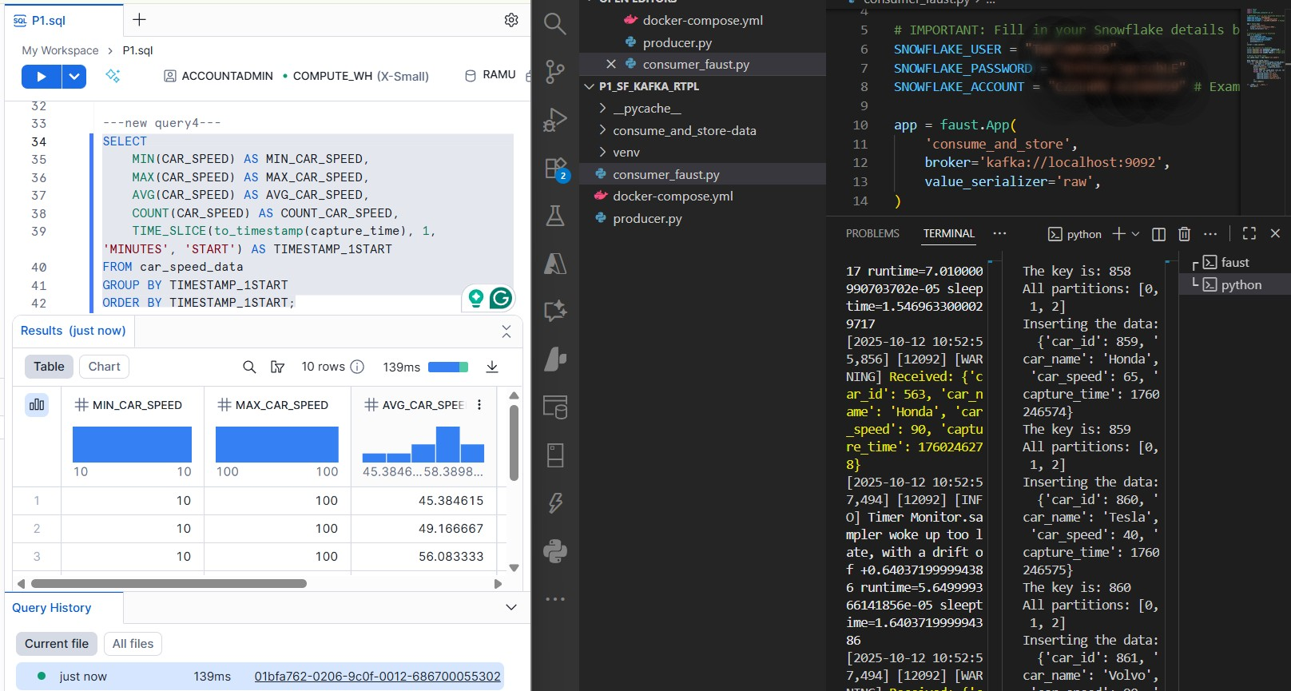
6. Last 5 rows of table
